Put your back into it!
November 2014 President's Message
Although fly fishing may look like a relaxing and beautiful sport to the casual observer, a sport of finesse and control, it frequently requires much physical stamina and energy. Perhaps I do it all wrong but I tend to go overboard with my hobbies.
On Thursday, October 23rd, David Beck and I headed down to Aransas Pass. Unfortunately we arrived after dark so fishing late Thursday afternoon wasn’t possible. We set up camp had a drink or two and discussed our plans for the following day. The conditions for the weekend were going to be ideal. Thanks to Todd’s presentation (Saltwater 101) I was encouraged to conduct research. The forecast was sunny skies, calm winds. It was going to be a wonderful weekend!
As with most fishing trips, Dave and I are usually up and at it very early. This trip we were both up at 4:00am. On day one, we are like two kids the day before Christmas. We are just wired that way I suppose. We enjoyed our coffee and then headed out. We left Tarpon Shores just before sunrise and headed to a cut we were told often held fish. Unfortunately that proved unproductive so we headed further back into Lighthouse Lakes. When fishing isn’t productive, we press on towards new water.
The bottom line here is that we paddled our backsides off in search of fish and it paid off. On Friday we caught fish between marker 21 and 24, near marker 25, and near marker 36. On Saturday we caught fish near marker 25, and marker 36, and 42. Sunday was a much easier day. Fish were caught near markers 4 and 5 which were much closer to our launch site.

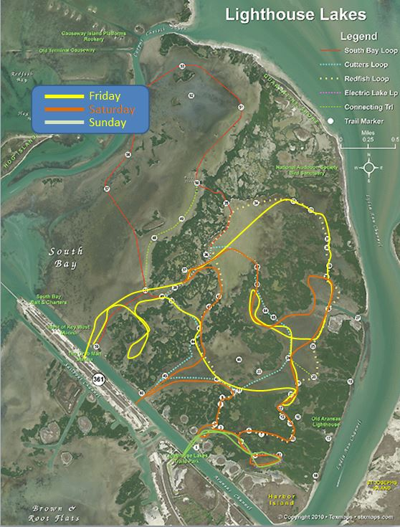
On Friday and Saturday we basically fished from sunrise to an hour past sunset. Needless to say we were tired and sore each evening like I said earlier Dave and I tend to go a little overboard with regards to our fishing addiction.
Although we didn’t limit out each day, we did catch many fish. Most were undersized and released but the keepers were taken home.
If you haven’t gone to Lighthouse Lakes lately, now is the time. Join us on our 7-9 November outing and fish at your own pace. Dave and I will be ‘putting our back into it!”
Tight Lines!
Walter Ross
President, AFF

